**Installing Ubuntu on Virtual Box:**

There are several ways to install Linux:

* Linux installation options:
  + Install Linux on windows
  + Or install Linux within windows from Microsoft Store.
  + Or without making any changes to Widnows OS, you can choose to virtual machine and install Ubuntu on that virtual machine.
* Download Virtual box from:
  + <https://www.virtualbox.org/>
  + Once it is downloaded, follow simple steps after running the exe to download
* Download Ubuntu Linux ISO from below link:
  + <https://www.ubuntu.com/download/desktop/thank-you?country=US&version=18.04.2&architecture=amd64>
  + Once the ubuntu is downloaded, we need to configure this in the virtual box as per below screenshots:
  + Name a machine that is to be created , select the appropriate version:

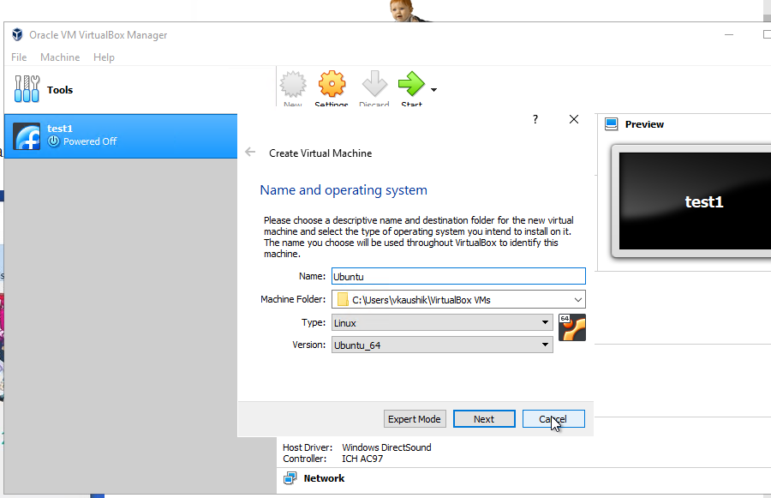

* I was not able to see the ubuntu (64 bit machine option) , to resolve that I had to go to BIOS setting of my Laptop and enable Virtualization , after that I saw 64 Bit version of Ubuntu
* Select the memory size as per below screenshot
* 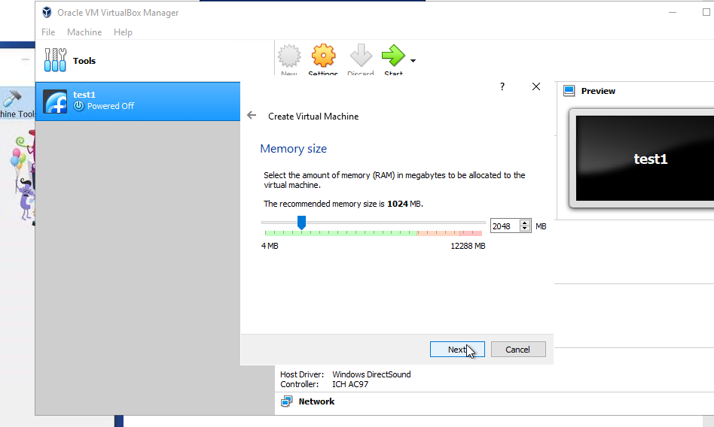
* Create a virtual hard disk as shown below

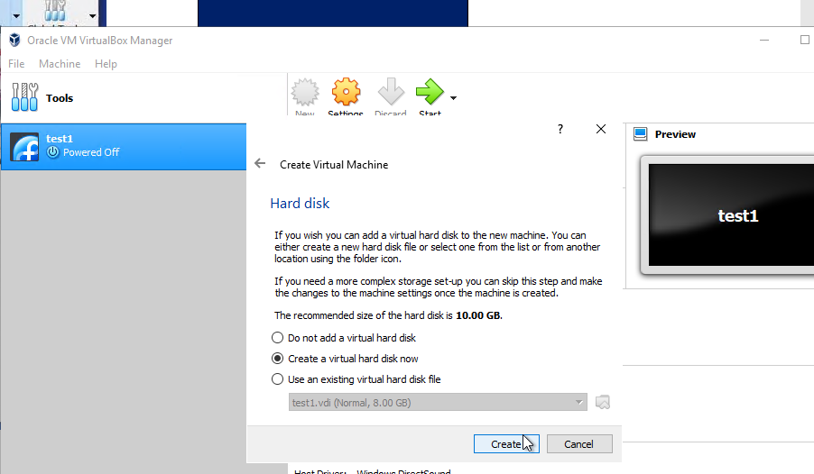

* Select Hard disk file type

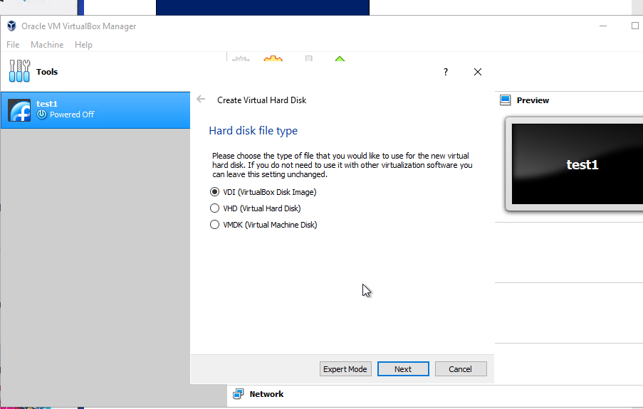

* Select storage on physical hard disk

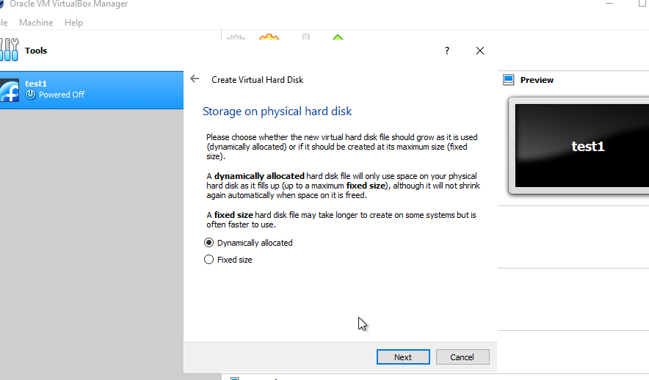

* Then select the file size and location:

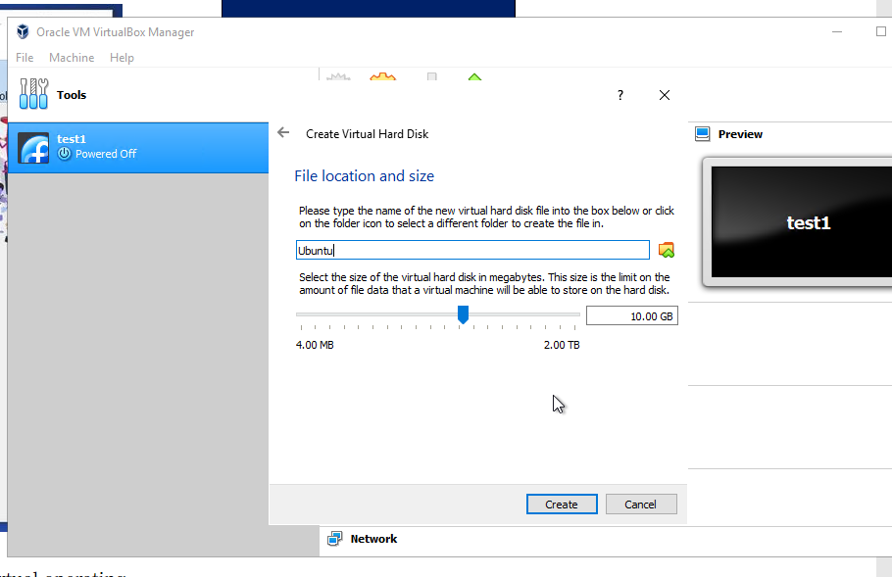

* Configure port forwarding as shown below:
* 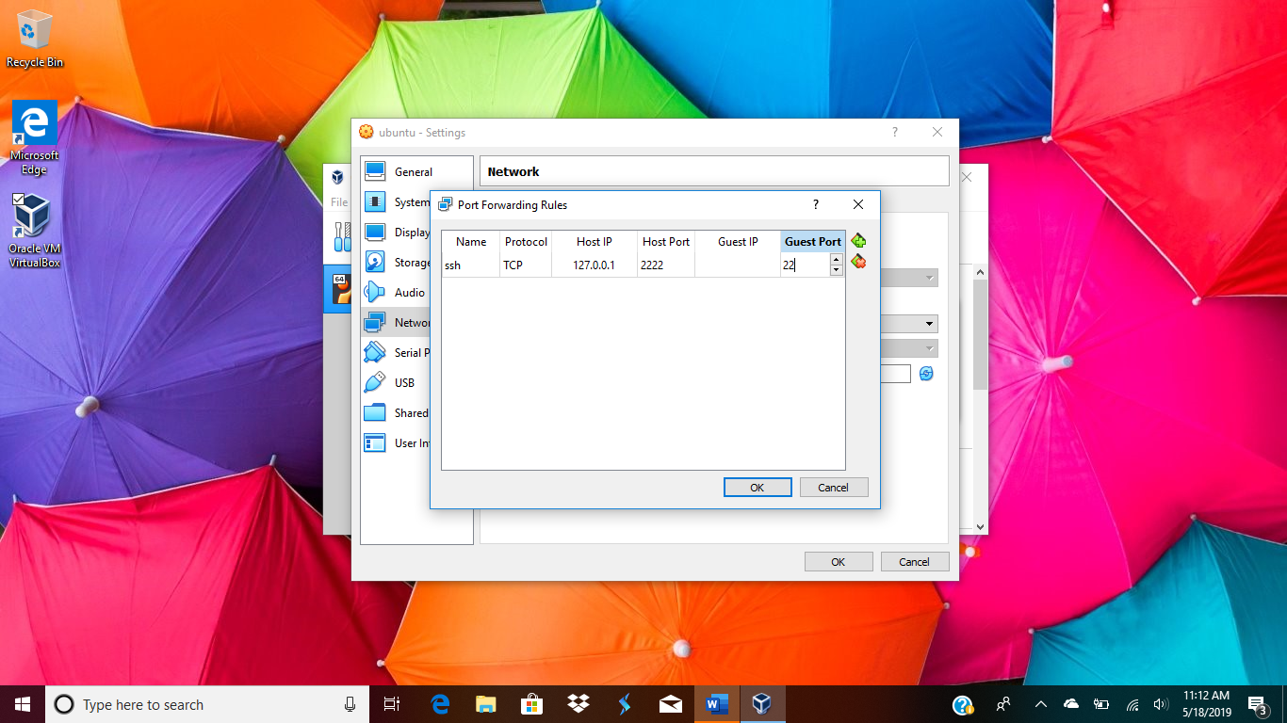
* Start install ubunut
* 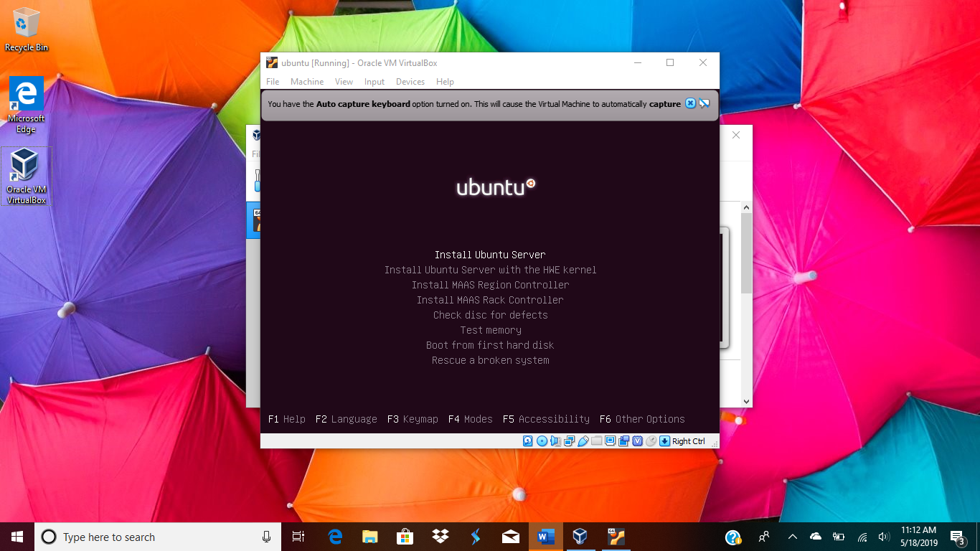
* Select the language as shown below
* 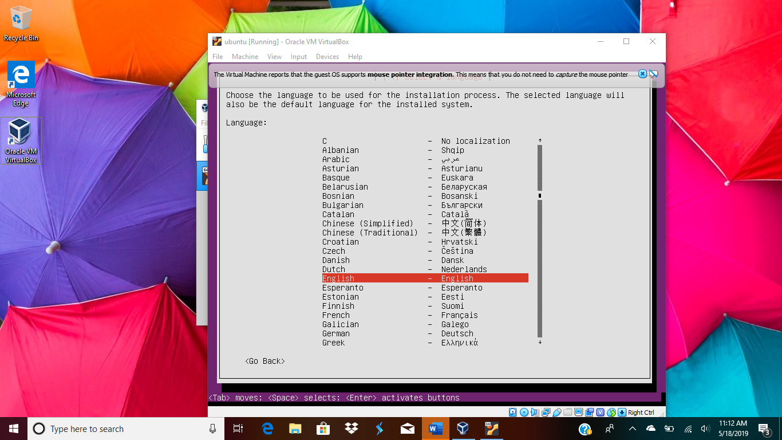
* 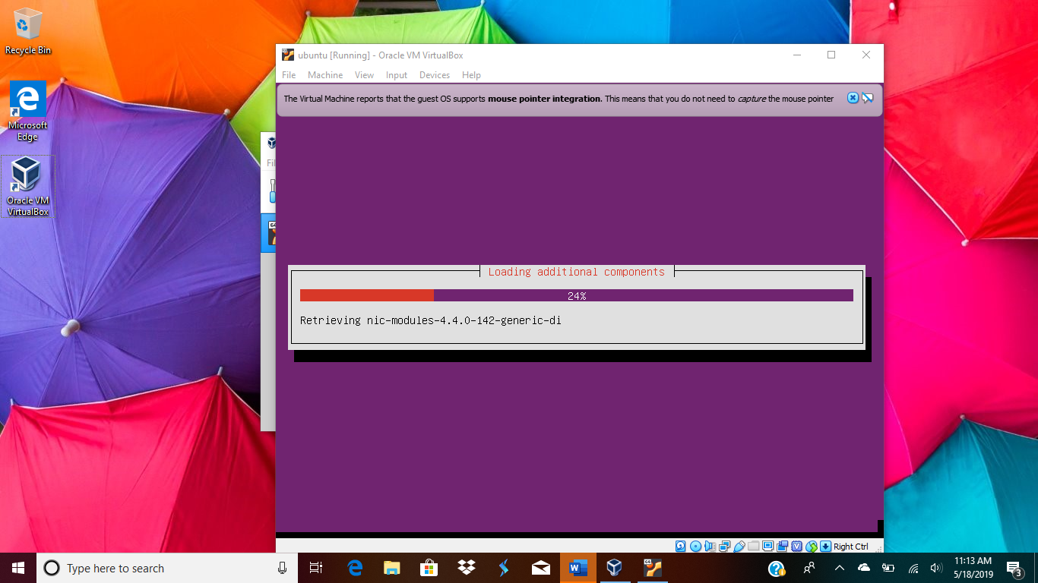
* Enter host name , I entered “ubuntu”
* 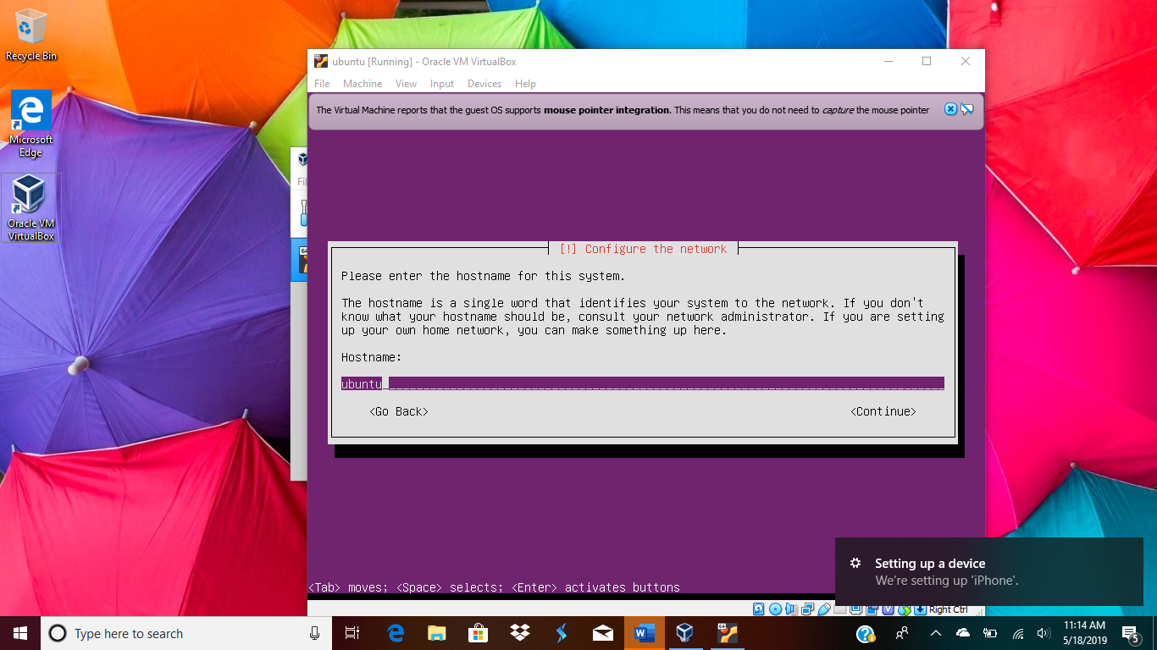
* Enter the username , I entered “vkaushik”
* 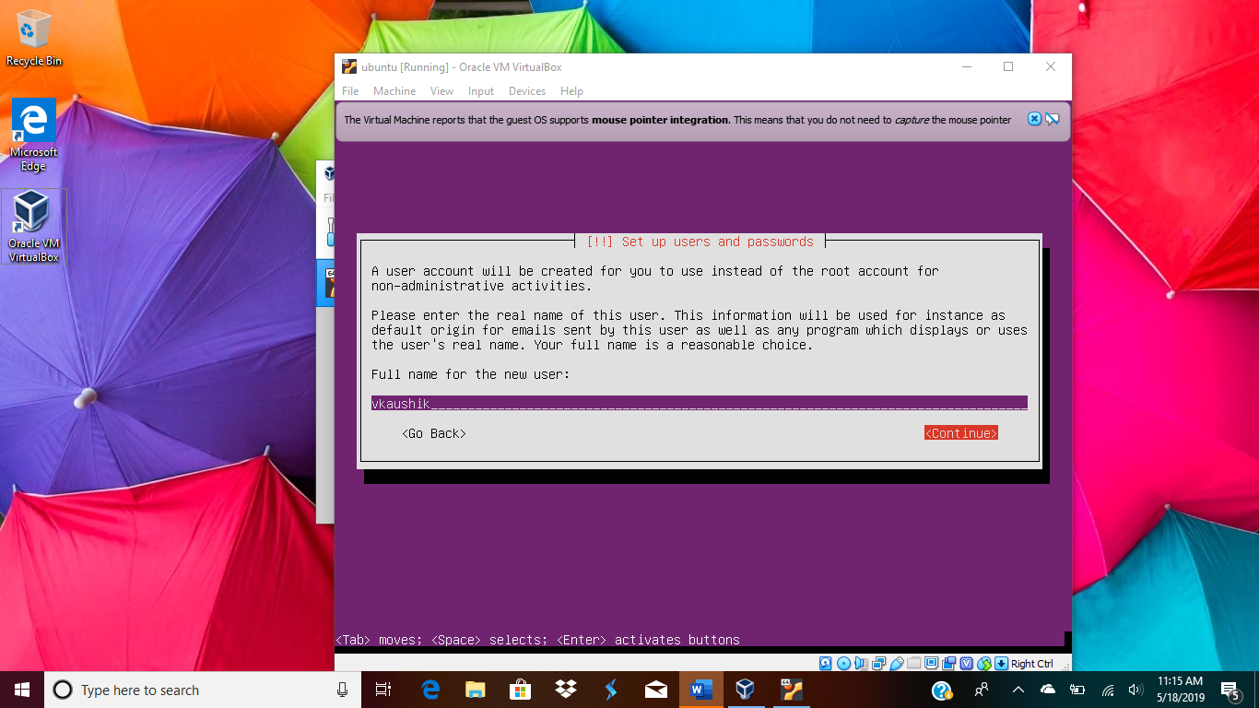
* Chose a password of your choice
* 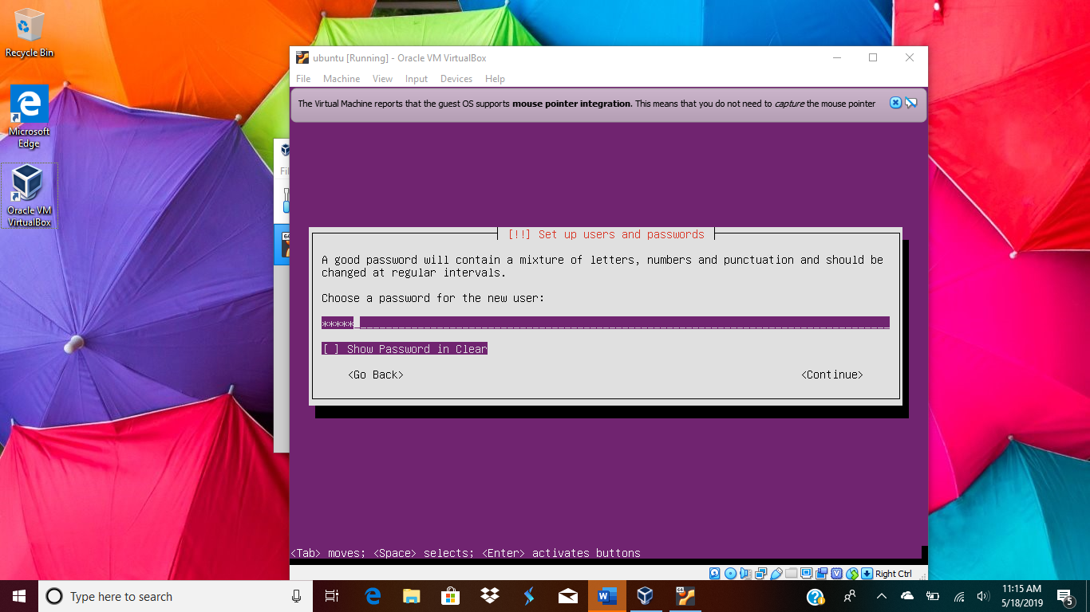
* Configure the clock
* 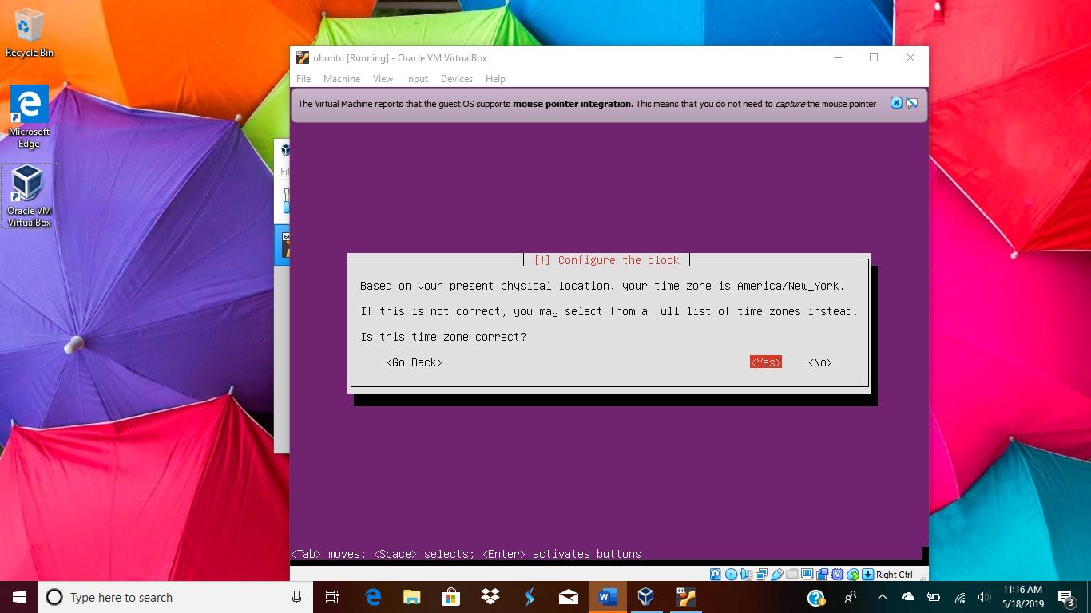
* Select disk partition:
* 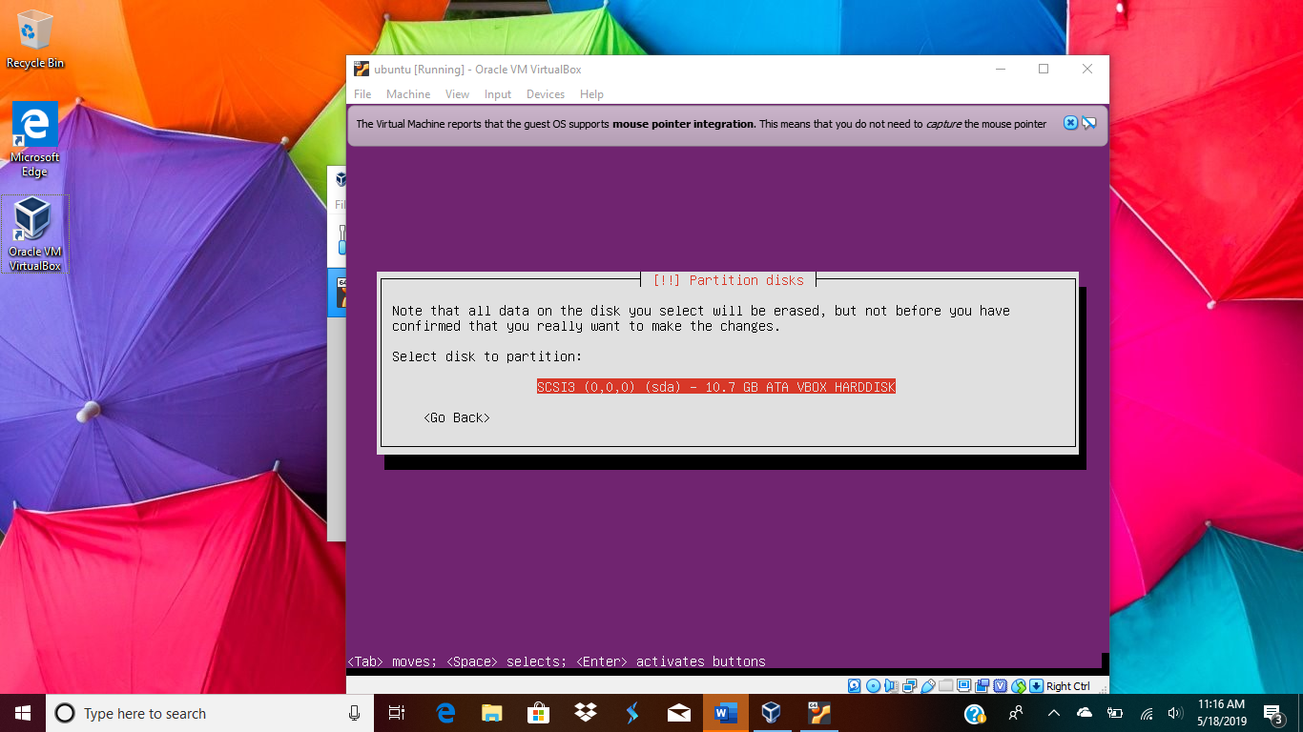
* 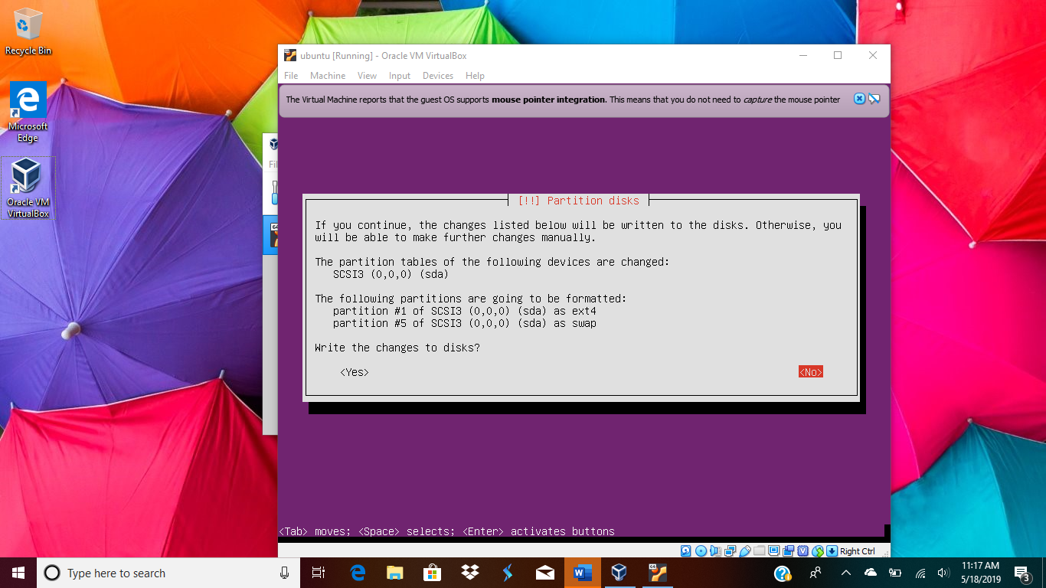
* 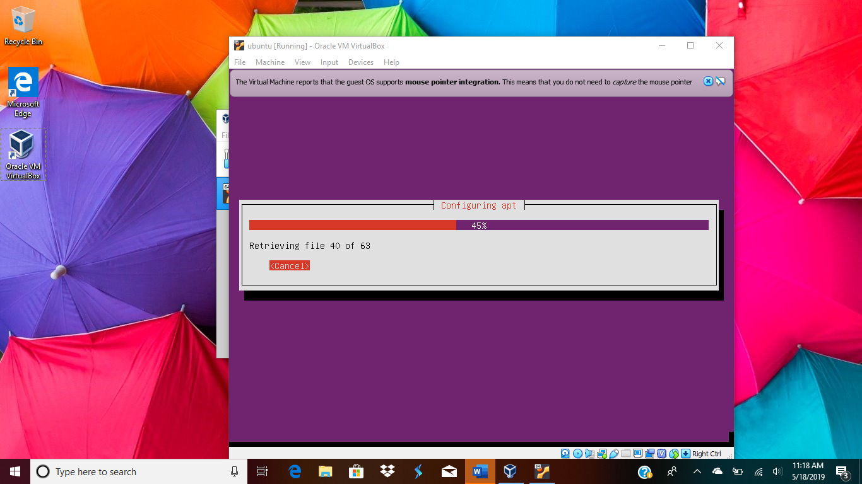
* Install the grub boot loader
* 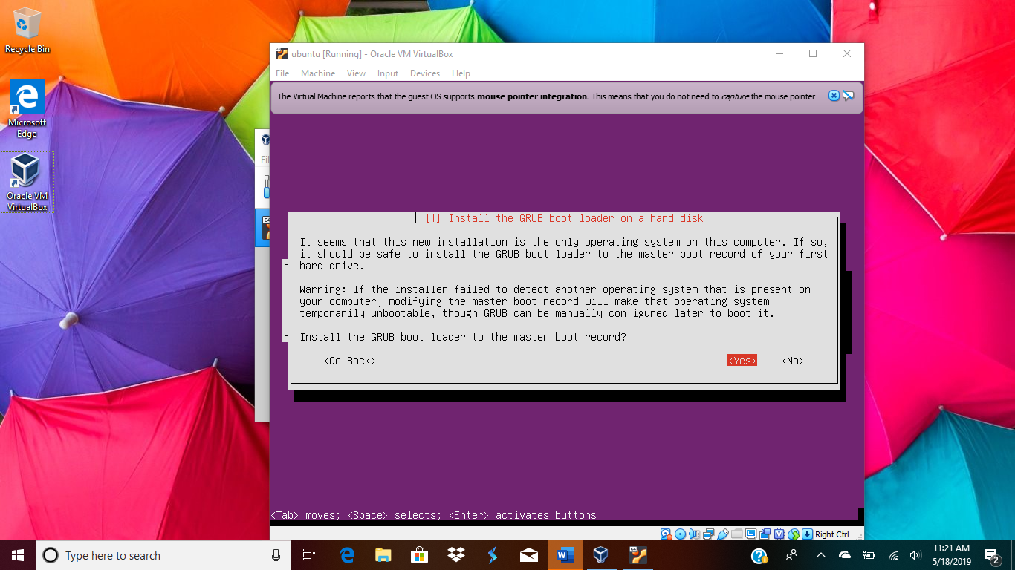
* 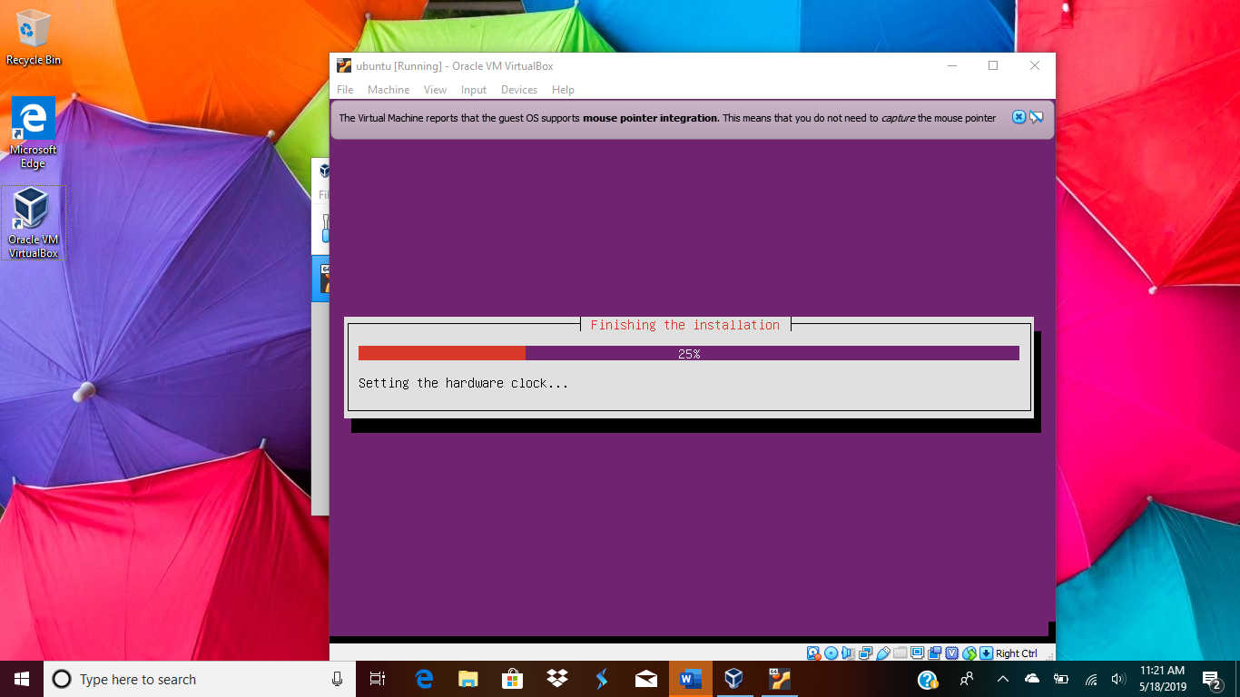
* Finish the installation
* 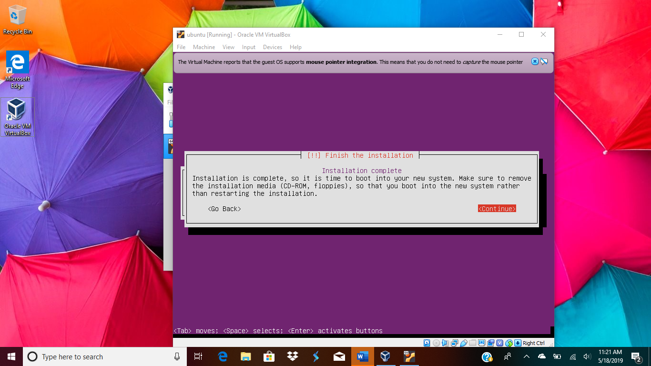
* 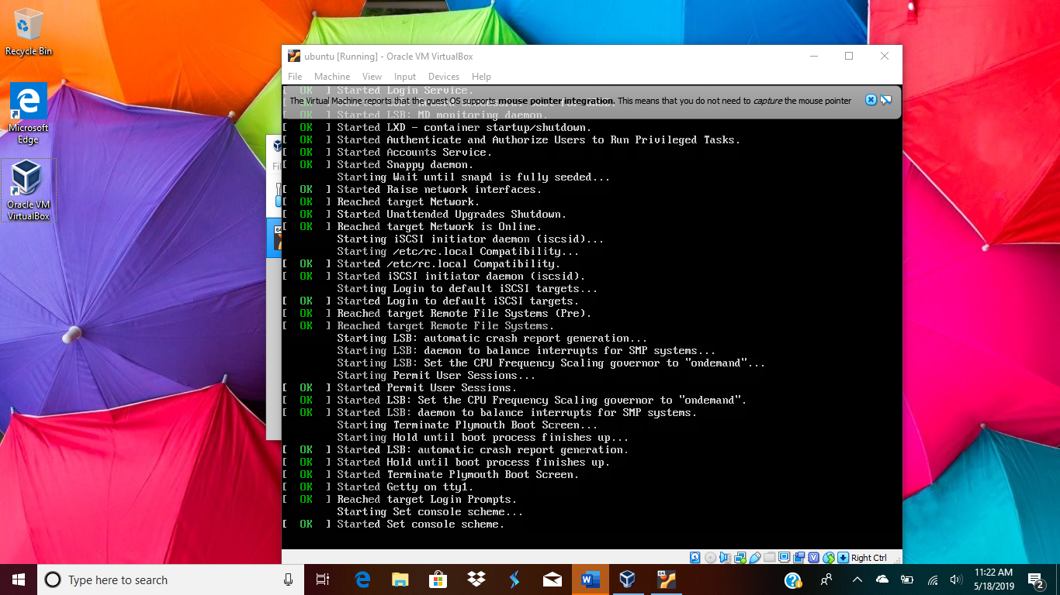
* Once the installation is complete, you can login with the crdetantials :
* 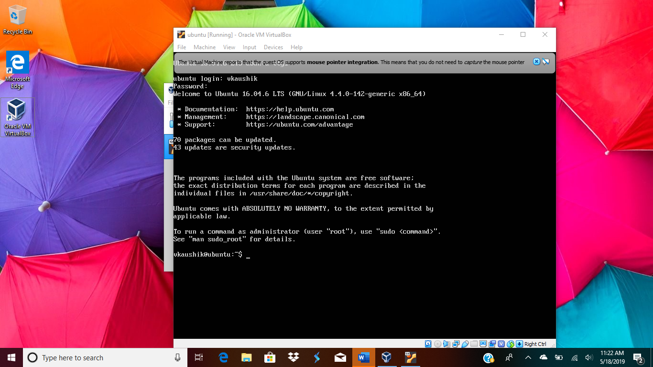
* Then I installed the python3 and upgraded pip
* 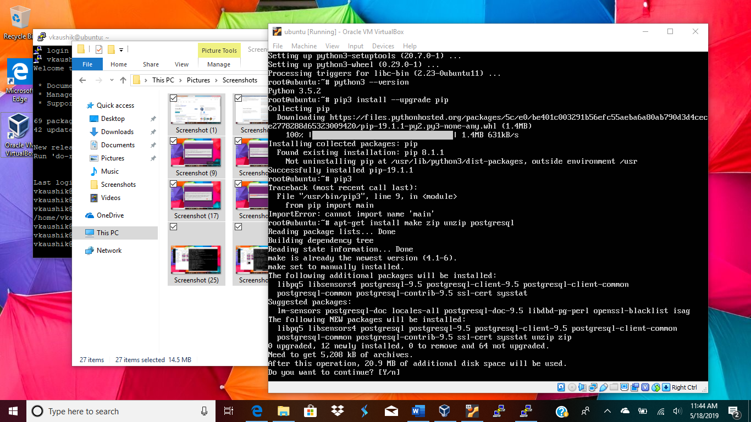
* 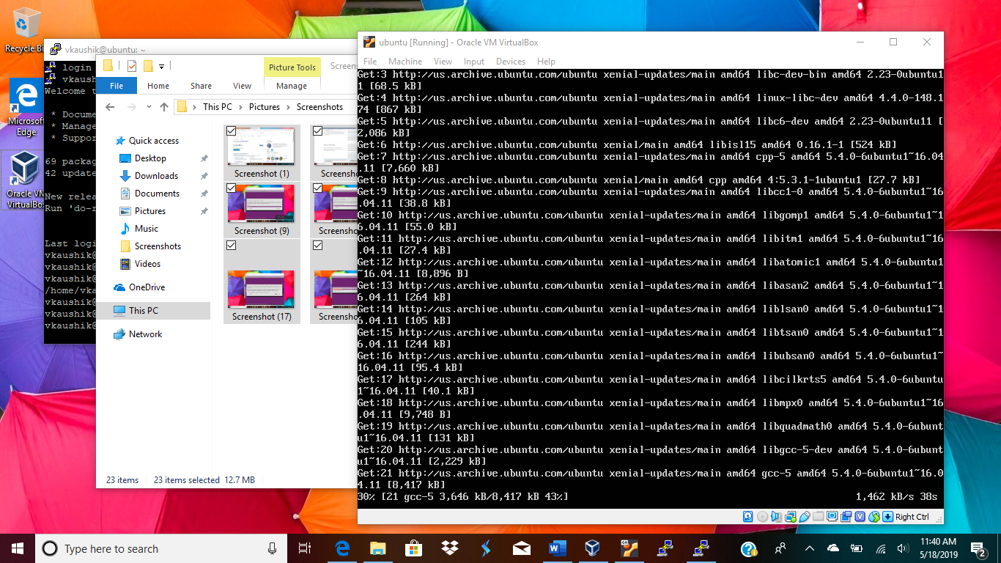
* 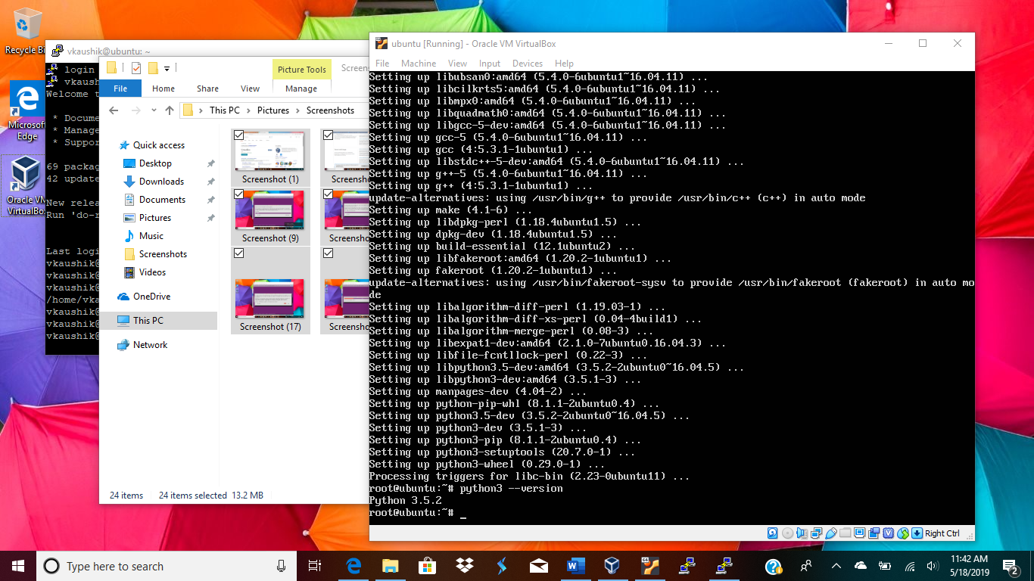

For connecting the ubuntu to putty: I had to install a secure server on ubuntu using command:

Sudo apt install openssh-server and then I was able to connect to putty client